<Date>

NAME:
ORGANIZATION:
ADDRESS:
DOB:
Dear ,

On behalf of the ATA, it is my pleasure to invite you to attend the ATA NEXUS 2026 Annual Conference (NEXUS 2026) to be held in Orlando, FL, May 12-15, 2026.
Our conference provides an opportunity for leading professionals from medical institutions, technology organizations, government, and the private sector to come together to share information and learn from one another. NEXUS 2026 will feature presentations and hands-on sessions that address the full spectrum of research and development, theory and application, and methodology and evaluation in matters pertaining to virtual care and digital health.

NEXUS 2026 is being developed in cooperation with several U.S. Government agencies and organizations.

Your attendance at this meeting is important as we look to learn from your experience with developing virtual care in your country.

To reserve a hotel room or register for the meeting please visit our website. If you have any questions, you may contact the ATA Events Team at mailto:events@americantelemed.org.

I hope to see you in Orlando, FL.

Sincerely,

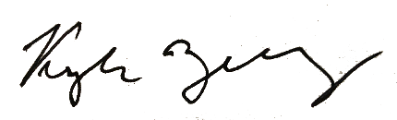

Kyle Zebley
Chief Executive Officer
American Telemedicine Association

